**Travelers**

**Software Requirements Specification**

Version 1.0



**Group Id: S2202303AC**

**Supervisor Name : Abdul Majid Khokhar**

**Revision History**

|  |  |  |  |
| --- | --- | --- | --- |
| **Date (dd/mm/yyyy)** | **Version** | **Description** | **Author** |
| 4/7/2022 | 1.0 | Travelers.pk is an online application for ticket booking for an Inter-city bus service.  Inter-city bus service is operating bus service within different cities. Currently it has three routes for which it is providing bus service. This website will provide the service for online ticket booking with fare calculation. | BC180402027 |
|  |  |  |  |
|  |  |  |  |
|  |  |  |  |

**Table of Contents**

1. Scope (of the project)
2. Functional Requirements Non Functional requirements
3. Use Case Diagram
4. Usage Scenarios
5. Adopted Methodology
6. Work Plan (Use MS Project to create Schedule/Work Plan)

**SRS Document**

**Scope of Project:**

Travelers.pk is an online application for ticket booking for an Inter-city bus service.

Inter-city bus service is operating bus service within different cities. Currently it has three routes for which it is providing bus service.

Routes are as following:

Route 1- Lahore to Multan [via Lahore->Sahiwal -> Multan]

Route 2- Lahore to Khushab [via Lahore -> Sarghodha -> Khushab]

Route 3- Lahore to Rawalpindi [via Lahore -> Gujranwala -> Jehlum -> Rawalpindi]

It has 2 categories of buses in its fleet.

* Business class
* Executive class

Fare of Executive class bus is higher than Business class bus.

This website will provide the service for online ticket booking with fare calculation.

This site offers a ticket booking with following facilities.

A ticket for a complete route.

For example route 2 - Lahore to Khushab

A ticket for substation of a route.

For example route 2 - Lahore -> Sarghodha

A ticket from substation to end of route station.

For example route 2 - Sarghodha -> Khushab

A return ticket

Travelers.pk website will provide real time seat availability and fare calculation when user want to book ticket. Fare calculation should be done w.r.t to bus selected.

**Functional and non Functional Requirements:**

1. **Passenger:**

A user must login the website in order to make a booking.

He must provide the passenger details along with traveling plan.

A passenger can schedule a advance booking maximum for 2 weeks.

Ticket information and status will be available in user’s dashboard on this website.

1. ***Admin***

Admin can update the:

route information

Fare rate and return policy

Generate reports regarding route travelings, sales etc.

1. **Fare charging:**

A ticket booked must be charged online via debut card, cradit card after confirmation of ticket.

1. **Ticket generation:**

A confirmed ticket will be sent to the mobile number of the passenger via sms or email.

Discounts:

A discount must be provided on a return ticket for complete route.

Use Case Diagram(s):

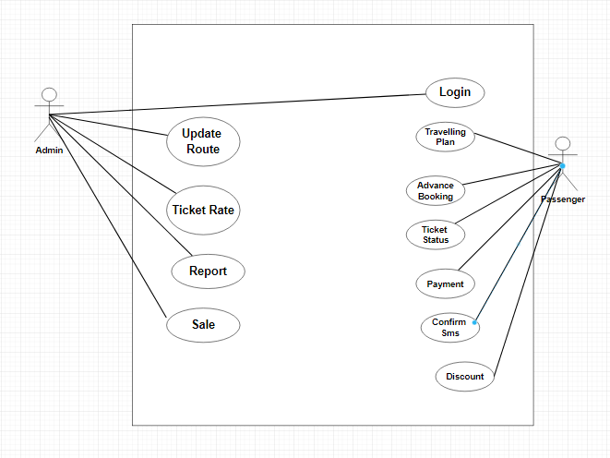

Usage Scenarios:

**Registration**

|  |  |
| --- | --- |
| **1.Use case title** | Registration |
| **2.Use case ID** | 1 |
| **3.Actor** | Passenger |
| **4.Action** | Passenger must be able to register yourself. |
| **5. Description**:Pssenger can register on the system and get his online account on Travel Pk. | |
| **5.1. Pre-conditions:** Passenger is on the registration page of a website. | |
| **5.2 Post-conditions:** Passenger has known successfully registered for the Travel Pk. | |
| **6.Exception: --------** Data enter Invalid | |
| **7. Author: BC180402027** | |

**Passenger Login**

|  |  |
| --- | --- |
| **1.Use case title** | Passenger Login |
| **2.Use case ID** | 2 |
| **3.Actor** | Passenger |
| **4.Action** | Passenger must be able to login yourself. |
| **5. Description**:Passenger can login on the system Travel Pk. | |
| **5.1. Pre-conditions:** Passenger is on the login page of a website. | |
| **5.2 Post-conditions:** Passenger has known successfully login for the Travel Pk. | |
| **6.Exception: --------**Email or password invalid | |
| **7. Author: BC180402027** | |

**Travelling Plan**

|  |  |
| --- | --- |
| **1.Use case title** | Travelling Plan |
| **2.Use case ID** | 3 |
| **3.Actor** | Passenger |
| **4.Action** | He must provide the passenger details along with traveling plan |
| **5. Description**:Admin Can give the complete traveling plan to the passenger for better Knowledge | |
| **5.1. Pre-conditions:** Admin Know The desire Location of the passenger where Passenger is going | |
| **5.2 Post-conditions:** Passenger View The Total Plan of the admin traveling Plan | |
| **6.Exception: -------**Passenger Not Like The Plan | |
| **7. Author: BC180402027** | |

**Advance Booking**

|  |  |
| --- | --- |
| **1.Use case title** | Advance Booking |
| **2.Use case ID** | 4 |
| **3.Actor** | Passenger |
| **4.Action** | A passenger can schedule a advance booking maximum for 2 weeks |
| **5. Description**:Our Website is ready for complete schedule for booking plan of 2 weeks | |
| **5.1. Pre-conditions:** Schedule Ready Successfully | |
| **5.2 Post-conditions:** Schedule Ready Successfully | |
| **6.Exception: -------** | |
| **7. Author: BC180402027** | |

**Status**

|  |  |
| --- | --- |
| **1.Use case title** | Status |
| **2.Use case ID** | 5 |
| **3.Actor** | Passenger |
| **4.Action** | Ticket information and status will be available in user’s dashboard on this website. |
| **5. Description**:Ticket information and status will be available in user’s dashboard on this website | |
| **5.1. Pre-conditions:** Passenger on the dashboard page and can view the status of the ticket | |
| **5.2 Post-conditions:** Ticket status is view successfully | |
| **6.Exception: -------** | |
| **7. Author: BC180402027** | |

**Payment**

|  |  |
| --- | --- |
| **1.Use case title** | Payment |
| **2.Use case ID** | 6 |
| **3.Actor** | Passenger |
| **4.Action** | A ticket booked must be charged online via debut card, cradit card after confirmation of ticket |
| **5. Description**:A ticket booked must be charged online via debut card, cradit card after confirmation of ticket | |
| **5.1. Pre-conditions:** Passenger book the ticket and give paymet | |
| **5.2 Post-conditions:**  after giving the payment the ticket is confirmed | |
| **6.Exception: -------** | |
| **7. Author: BC180402027** | |

**Confirm Message**

|  |  |
| --- | --- |
| **1.Use case title** | Confirm Sms |
| **2.Use case ID** | 7 |
| **3.Actor** | passenger |
| **4.Action** | A confirmed ticket will be sent to the mobile number of the passenger via sms or email |
| **5. Description**:A confirmed ticket will be sent to the mobile number of the passenger via sms or email | |
| **5.1. Pre-conditions:** Passenger can vies the status of the ticket | |
| **5.2 Post-conditions:**  Payment successfuly | |
| **6.Exception: -------** | |
| **7. Author: BC180402027** | |

**Discount**

|  |  |
| --- | --- |
| **1.Use case title** | Discount |
| **2.Use case ID** | 8 |
| **3.Actor** | Passeger |
| **4.Action** | A discount must be provided on a return ticket for complete route. |
| **5. Description**:A discount must be provided on a return ticket for complete route. | |
| **5.1. Pre-conditions:** A discount must be provided on a return ticket for complete route. | |
| **5.2 Post-conditions:**  passenger get the discount. | |
| **6.Exception: -------** | |
| **7. Author: BC180402027** | |

**Adopted Methodology**

The adopted methodology for this project is VU process model. VU process model is a combination of waterfall model and spiral model. This combination has many advantages. Basically this process model explains the simplified description of software process in iteration to avoid maximum risk. These methodologies help to successful delivery of product. However two methodologies can also be combines like VU model combines waterfall and spiral model. This model is easy to understand and use.

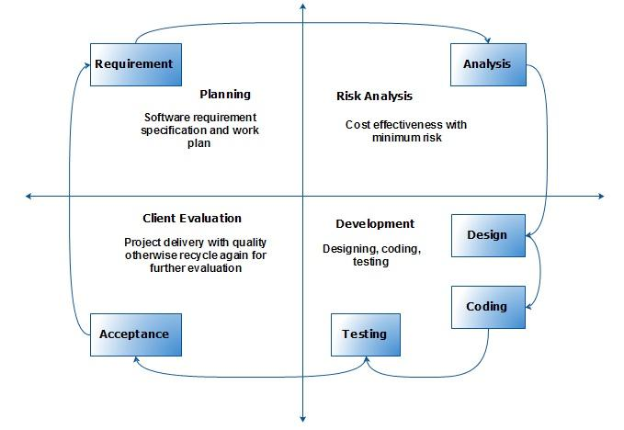

Work Plan (Use MS Project to create Schedule/Work Plan)

